act five, scenes 8 and 9

Act Five, Scene Eight
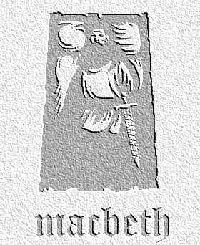
overview

Macbeth finally faces Macduff and learns he was not naturally ‘born of woman’. The man whose family he slaughtered finally kills him. In the next scene, Macduff returns Macbeth’s severed head to a victorious Malcolm, who vows to return Scotland to peace when he is crowned king.
- ‘Of all men else, I have avoided thee...my soul is too much charged / With blood of thine already.’ Explain why Macbeth is reluctant to fight Macduff in this scene.

- Macbeth gives a reason why he intends to die fighting, even though he knows he is about to lose. What is it?

- Imagine the play as a novel. Describe, in fifty words, the moment of Macbeth’s death at the hands of the vengeful Macduff.

Act Five, Scene Nine
- ‘Enter MACDUFF with Macbeth’s head’. What do you think of this stage direction? How would you handle it if your were the director of the play. Think about the effect that you want it to have on the audience.

- Read Malcolm’s final speech of the play again. Re-write this in Modern English. Do you find it a convincing speech ? Which original words would you keep in for emphasis?

CLASS DEBATE

‘This dead butcher and his fiend-like queen’

Do you find this a fair summary of the lives of Macbeth and Lady Macbeth in the play? Half of your class can write argument defending this statement, half attacking it. Use the arguments as the starting points for a debate or discussion. Remember to use evidence and quotations from the play itself to back up your ideas.

