act five, scene 5, 6 and 7

Act Five, Scene Five
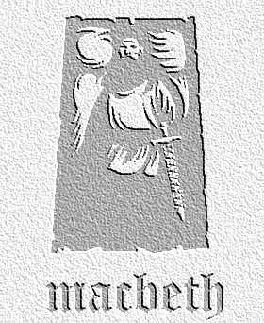
overview

Ignoring all warnings of defeat, Macbeth shows no fear. He receives news of his wife’s death. Hearing that Birnham Wood is moving nearer and engages in battle, killing Young Siward. Meanwhile, Macduff will only be satisfied can meet Macbeth and take revenge…
- Imagine Seyton’s thoughts as Macbeth delivers the first seven lines of this scene. What might you be thinking about the state of mind of your king?

- Why do you think Macbeth has ‘forgot the taste of fears’? List the reasons he has for no longer feeling afraid of what might happen to him.

- ‘The queen, my lord, is dead.’ We are never told how she dies, although Malcolm hints later that she takes her own life. In pairs, write a suicide note of 100 words that she would write for Macbeth, detailing why she did it.

- Lines 18-27 (‘Tomorrow...signifying nothing’ are among the most famous in the play.
- Why do you think these lines continue to make such an impression upon all who hear them. Can you think of five reasons?
- Consider how you would advise an actor playing Macbeth to deliver these lines. Think about speed, mood and emphasis of certain words. What would he be doing while he delivered them?

5. Why does Macbeth react so dramatically to the news about Birnham Wood coming to Dunsinane? What are the long-term consequences of this for him?

Act Five, Scene Six
- Speaking and Listening This sequence of scenes needs to be fast-moving and smoothly-run on stage. In small groups, discuss how you would move from scene five, into six and then into seven in terms of props and background. You could draw diagrams to clarify your ideas, and present them to the rest of the class.

Act Five, Scene Seven
- Shakespeare uses a variety of techniques to ensure that this scene is action-packed and dramatic. Use these key words to explain how he does this:
- stage directions
- entrances and exits
- verbs
- exclamations
- images of war / violence

