act five, scene 2, 3 and 4

Act Five, Scene Two
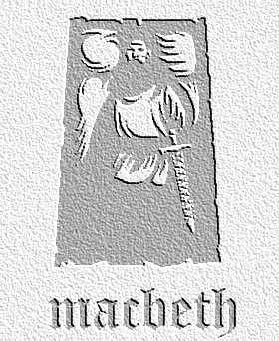
overview

Malcolm, Macduff and the English army approach while Macbeth faces rebellion within. Macbeth clings on to the witches’ predictions for hope, and vows to fight to the death. Desperately, he calls for his armour.
- The speakers in this scene are full of hope that they can defeat Macbeth. List the reasons that are given for them being so hopeful of success, alongside the quotations that back your points up.

- ‘Mad’ or ‘Valiant Fury’? Caithness expresses two views held of Macbeth. Head two columns with these quotations, writing as many arguments that back up each point of view as possible.

- A giant’s robe upon a dwarfish thief Who is Angus referring to and what do you think he means by this? Why is it a particularly good description?

Act Five, Scene Three
- In his opening speech, Macbeth refers to the witches’ prophecies. Translate this into Modern English, then explain his way of thinking at this point in the play.

- List the insults that Macbeth throws towards the servant. What does this tell us about the soldier, and what about Macbeth’s state of mind?

- In lines 22-28, Macbeth speculates about his future. He describes himself as having lost honour, love, obedience and troops of friends. List these qualities down the page, and write alongside each the point in the play where he most obviously lost that quality.

- Explain how Macbeth’s conversation with the doctor moves from discussing his wife’s condition to discussing the condition of Scotland. Why is the idea of Macbeth asking for a cure for the ills of Scotland ironic?

Act Five, Scene Four
- What are Malcolm’s plans as his army nears Dunsinane? Why does he suggest this, and how does it relate to one of the witches’ predictions?

