act five, scene 1

Act Five, Scene One
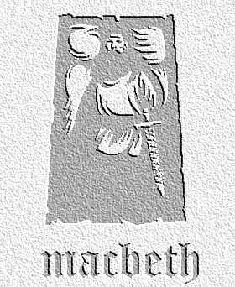
overview

The gentlewoman tells the doctor that she has seen her mistress, Lady Macbeth, sleepwalking. As they discuss this, Lady Macbeth enters, asleep, apparently reliving recent events…
- The doctor calls sleepwalking ‘a great perturbation in nature.’ Look the word perturbation up in the dictionary, and write a definition in your own words. What other perturbations in nature can you remember from previous acts?

2. Consider what Shakespeare could mean by including the following details:
- The fact that Lady Macbeth carries a light, even though she is asleep
- The fact that she sleeps with her eyes open
- The way she continually rubs her hands
What other events and characters can you link / compare the first and third points to in previous acts?

3.After she enters the stage, Lady Macbeth refers to various events of the recent past, as though she is reliving them in her disturbed sleep. Which areas of the play do the following quotations refer to? Name the events, and the scene(s) in which it happens for each:
- Fie, my lord, fie, a soldier, and afeard?
- …who would have thought the old man to have so much blood in him?
- The Thane of Fife had a wife.
- He cannot come out on’s grave.
- There’s knocking at the gate.

Comment on the order in which Lady Macbeth confronts each of these events.

4. Explain the doctor’s words at the end of the scene. What kind of atmosphere does this add to this area of the play?

Prose or Verse
Look at the way prose (not written in poetry) and verse (poetry) are used in this scene. Find other areas of the play when Shakespeare writes in prose. See if you can make up some rules about when he decides to use it.

Directing the scene
This scene is difficult to direct in terms of the movements of characters. Through a series of overhead diagrams, show how you would position the three characters at various points in the scene. Take care to ensure that Lady Macbeth is the centre of attention throughout her appearance.

