act four, scene 2

Act Four, Scene Two
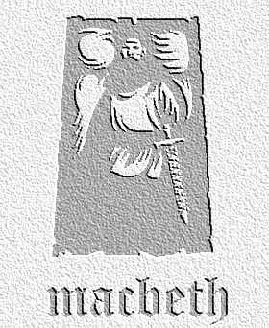
overview

Lady Macduff describes how Macduff has let her family down by leaving the country. Ross tries to comfort her, and she enjoys time with her son. A messenger arrives to warn of sudden danger, but it is too late…

Lines 1-29
- What are the reasons Lady Macduff can think of for her husband deserting them as he has? How does Ross try to reassure her?

- Why do you think Lady Macduff describes her husband so: ‘Fathered he is, and yet he’s fatherless.’

- ‘…should I stay longer / It would be my disgrace and your discomfort.’ Why do you think some people have seen these lines as meaning that Ross knows what is about to happen to Macduff’s family?

Lines 30-61
- The following lines are taken from Lady Macduff’s conversation with her son. How might they be taken to have a deeper meaning that refers to events that have happened so far and characters we have seen?

- …that swears and lies
- …a traitor and must be hanged
- the honest men

- How do you think Shakespeare wants the audience to react, knowing what happens to this loving scene between mother and child? What new light is shed on Macbeth’s character?

Lines 62 – end of scene
- Showing the audience the murder of a child on stage can be very disturbing. What are the possible ways of staging this last sequence so as to make an impression on the audience, but not produce anything too over the top.

- The murderer calls Lady Macduff’s son two names: ‘fry’ and ‘egg’. What have these two things in common (look up ‘fry’ as a noun – it has nothing to with cooked breakfasts!) and how might they fit into the play as a whole?

