act four, scene 1

Act Four, Scene One
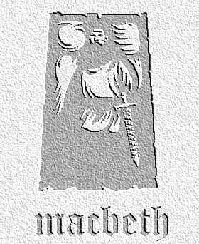
overview

The witches meet once again with Macbeth, and show him a series of apparitions and visions that warn him about his future…

Lines 1-46

- Draw up a table with three columns. Head the columns with the titles: ‘Nouns’, ‘Verbs’ , and ‘Adjectives’. Concentrating on the witches’ ingredients, list the words Shakespeare uses in the right categories. Now use your results to try to describe the effect of his use of images and languages in this section.

- Look at the chant again. Count the average number of syllables in each line, and read the lines aloud to work out how many of the syllables are stressed per line. This will help you work out the rhythm. How does it differ from the rhythm in other areas of the play? Also, try to describe the pattern of rhymes used here, and compare it to elsewhere.

Lines 47-99
- In lines 47 – 59, Macbeth describes a series of large disasters that the witches might be responsible for. Look back to Act II.4 – what similarities can you note between the two scenes? Why do you think Shakespeare is so concerned with presenting the world in such a chaotic and confused state at these points in the play?

- Copy the table below, filling in the details about the three apparitions.

apparition | What it says / what it does | Macbeth’s reaction | What the apparition might mean
The armed Head

The bloody Child

The crowned Child with a tree

- Read the section where the witches make the ‘show of eight kings’. Write down what you think this might mean.

Lines 100 – end of scene

- How does Shakespeare show Macbeth’s reaction (lines 111-123) to this vision through his use of language? To help, look at:

- The way he builds up tension through them appearing one by one
- The words he uses to describe the sight and accuse the witches
- His use of punctuation to show surprise
- The images of royalty to hammer the point home
- The use of alliteration to show Macbeth’s fury against Banquo

8. Remind yourself of Lennox’s doubts about Macbeth in Act Three scene 4. What do you think might be going through his mind as he speaks with Macbeth? Write a diary entry he might write after this conversation. (NB – also make a note in your book to spot Lennox’s next appearance in the play in Act 5 to see how this conversation really affects him!)

Extension Activities Based on the Whole Scene

1. Writing to Inform / Explain / Describe ; Analyse / Review / Comment Like other Shakespearean tragedies, Macbeth has been produced in many different ways. Use the worksheet to describe different ways you might stage aspects of Act Four scene 3 if you were directing a production set in a) a period of the past b) the present day or c) the future. (Accompanying worksheet available)

1. Writing to Explore, Imagine, Entertain After his first visit to the witches (Act One, scene three) Macbeth writes a letter to Lady Macbeth, outlining events and describing his thoughts and feelings. Write another as Macbeth, having spoken to the witches a second time and seen the apparitions. Remember to include:
- how he felt about each of the apparitions;
- what his reactions to these and the show of kings were;
- what his aims and hopes for the future now are in the light of these things.
Try to get behind what he might be feeling emotionally at this point in the play.

