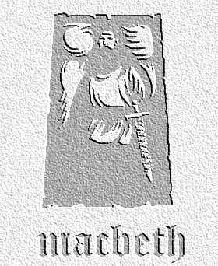
INTERPRETATIONS Writing to Inform, Explain, Describe ACT IV Scene 1
Task: How would you present this scene to the audience if this was a production of Macbeth set in:
a) the past (decide on which area of the past) b) the present day and c) the future
Use this table to record your ideas
 | The Witches | Macbeth | Show of Kings
Past: | COSTUME | COSTUME | COSTUME
Past: | PROPS | PROPS | PROPS
Past: | EFFECTS / SOUNDS / LIGHTING, ETC. | EFFECTS / SOUNDS / LIGHTING, ETC. | EFFECTS / SOUNDS / LIGHTING, ETC.
Present Day | COSTUME | COSTUME | COSTUME
Present Day | PROPS | PROPS | PROPS
Present Day | EFFECTS / SOUNDS / LIGHTING, ETC. | EFFECTS / SOUNDS / LIGHTING, ETC. | EFFECTS / SOUNDS / LIGHTING, ETC.
Future | COSTUME | COSTUME | COSTUME
Future | PROPS | PROPS | PROPS
Future | EFFECTS / SOUNDS / LIGHTING, ETC. | EFFECTS / SOUNDS / LIGHTING, ETC. | EFFECTS / SOUNDS / LIGHTING, ETC.

