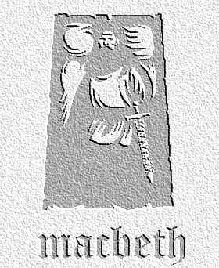
Writing to Inform, Explain, Describe : Diary of a Lord at Macbeth’s Banquet
Task: Imagine you are one of the lords at the banquet. Write a diary extract written on the night after the banquet. Describe your new king’s behaviour, explain what you think it might mean, and write about your reaction to it. Use this table as a plan to help you with your work. The first one has been done for you!
Line Numbers | Key Moments in Dialogue | Macbeth’s Behaviour | Others’ Behaviour | Your Reactions / Thoughts
1-8 | ‘Our self will mingle with society and play the humble host.’ | Trying to impress guests – showing he’s in control | Lady M working well with M – other lords in good mood | Please to be here – want to see how Macbeth will perform as King – as good as Duncan?
9-37

38-73

74-107

107-end

