act three, scene 3

Act Three, Scene Three
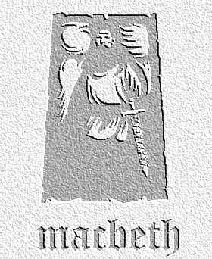
overview

A third murderer joins his two comrades who are waiting to kill Banquo. In a short action-packed scene, they do the deed- but Banquo’s son, Fleance, escapes…

1. Look back to Act Two, scene 1, where Banquo talks to Fleance. Note the references to light in the first ten lines. Find down all the references to light in this scene also. Why do you think this is important?
2. Some critics have suggested that the third murderer who joins the other two could actually be Macbeth. Re-read the scene bearing this in mind, and with a partner, discuss how your reading of the scene changes and what you think the main arguments for and against this theory might be.

3. In the scene, Banquo is murdered, but Fleance survives. How does this link back to one of the predictions of the witches in Act One, scene Three? Which line makes you feel that the murderers might be aware of this?

4. In groups of four to five people, discuss the staging of this scene. Do this in these stages:
- What are the problems that the director faces?
- How might you overcome these problems?
- What are the most important elements of the scene to get across to the audience?

You might want to draw out overhead views of the stage so that you can indicate how the various characters move about.

