act three, scene 1

set SATS
scene!

Act Three, Scene One
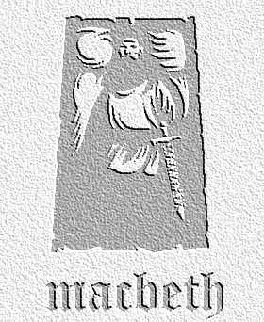
overview

Banquo ponders and worries about how Macbeth has become king, but says nothing to him. Macbeth considers the threat Banquo poses, and promptly arranges his murder…

Lines 1-10

- Summarise Banquo’s thoughts in three sentences of Modern English, as if you were Banquo writing.

- ‘…Thou played’st most foully for’t.’ What is the significance of these words?

Lines 10-49

3. Why is Macbeth .so interested in Banquo’s plans for the afternoon?

- What does Macbeth say about Malcolm and Donaldbain, Duncan’s sons? Why would he spread such lies?

Lines 50-73

- In his soliloquy, Macbeth makes a number of references to the fact that his kingship is worthless if it is under constant threat. Copy down all the images and references you can find in connection with this, explaining each one in your own words. Set your answer out as a table like so:

Quotation | Comment
a fruitless crown  (III.1.62) | Metaphor to echo point witches made that Macbeth will ‘get’ no kings, i.e. that he will have no children that become king

Lines 74-141

- What do you notice about the way Shakespeare sets the first part of this section? Why do you think it differs from how most of the play is set out? Clue: look at the type of character Macbeth is speaking to.

- Macbeth has a servant guarding the door while he speaks to these murderers. What other touches could you, as the director, bring to this scene to make the meeting seem as underhand and disturbing as possible? Write down your ideas in rough and compare them with a partner.

Activities based on the whole scene

- Writing to Inform / Explain / Describe

Compare Macbeth’s behaviour in this scene to his behaviour just after killing Duncan. Do you notice any changes in his character or the way he is acting? You could plan your answer by putting quotations from each scene alongside each other to prove your points, then commenting on each.

- Writing to Argue / Persuade / Advise

At this stage in the play, Macbeth is contemplating more murders to ensure that his grasp of the crown is firm, and that his descendants can also become king. Imagine you are a close friend of his. Write a letter of around 250 words persuading him to either go ahead with this course of action or stop where he is. You must list as many reasons for your point of view as possible, taking them where you can from the play itself.

