act two, scene 3

Act Two, Scene Three

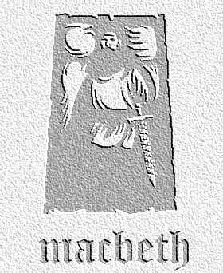
overview

Macduff discovers the dead body of the king, and other characters respond and act. Duncan's sons flee the country.

Lines 1-55

1. The Porter Scene. Look at this section at the beginning of the scene. It is the only moment of real humour in the play. List three reasons why you think Shakespeare might have written this in at this point in the play. (Clue: think about what has just happened).

2. Read Lennox’s description of the ‘unruly’ night (lines 46-53). Write this section as a modern newsreader’s headlines in Modern English. What might be the reason for all these disturbances? Comment on Macbeth’s response to what Lennox says.

Lines 56-113

3. ‘O horror, horror, horror...' In pairs rehearse how you might deliver this line onstage. What must you convey to the audience?

4. Macduff is the character who responds the most dramatically to Duncan’s death. Find all the references he makes to Duncan in this section. How do they give an impression of how Duncan is generally though of by all?

5. Macbeth delivers the following lines in this section:
- renown and grace is dead
- the fountain of your blood is stopped
Why would Shakespeare give these lines to Duncan’s murderer? Also, what is the effect of him then claiming to have killed Duncan’s guards, saying that they were guilty of the murder?

6. Lady Macbeth faints after Macbeth’s speech. List reasons why this might be so – and whether you think it is genuine or ‘false face’?.

Lines 113 - 139

7. What course of action do Duncan's sons, Malcolm and Donaldbain, decide to take? In your notes, draw a table with two columns headed 'plus' and 'minus'. Write down the good and bad things that might result from them doing this.

8. Banquo and Macbeth both make statements about how they intend to respond. Copy down the relevant quotations, and explain how each quotation shows the audience the difference between the two men.

Activities based on Act Two, Scenes 1-3

1. Writing to Inform / Explain / Describe (Accompanying worksheet available)
'Renown and Grace is Dead.' Design and write the front page of a Scottish newspaper announcing the murder of Duncan. You should use information from the first three scenes in Act 2 to write your account. Remember that, as the writer, you only know what Macduff and Banquo know; and that you should include the following:
- details of where it happened
- how the murder was discovered
- what was found at the scene of the crime
- how other characters responded and acted (you could use quotations from the play here)

You could also include a second story on the front page linked to the play. Here are some suggestions:

- the war against Norway
- the execution of the Thane of Cawdor
- the sighting of the witches on the heath

The worksheet will help you lay out your article.

