INSIDE today’s Herald:
-The Inverness Herald
www.anachronism.com Monday, January 11 - 1040 Edition 556 8 Three Pebbles

Renown and Grace is Dead!
Subheading

Above:Leading article

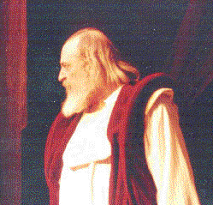

Title of second article

by...

title of third article

by...
by...
Inside...

advert

Political cartoon

Picture relating to third article
King Duncan, shortly before his arrival at Macbeth's castle in Inverness

