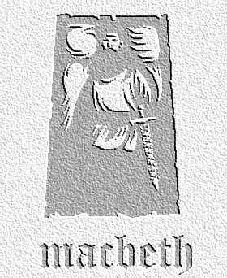
Writing to Inform / Explain / Describe; Analyse / Review / Comment
Task: Lady Macbeth is clearly experiencing many emotions at this point in the play. Write down the notes of an actress taking her part, stating how she might approach II.2. Use key quotations from the scene as your starting points.
LINES | KEY QUOTATION | EMOTIONS | NOTES
1 /2 | '…hath made me bold…' | Confident, excited | Rubbing hands, animated expression - looking towards door for Macbeth, standing and pacing, glass in hand
3-7
8-13 |  | Doubt, anxiety, sadness over father
14-24
25-37 | 'Consider it not so deeply.'
38-53
55-59
67-end

