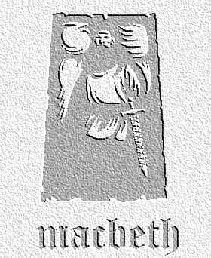
Narrative Writing Task: Act Two Scenes 1 and 2 – Before and After Duncan's Murder
Task: Write a descriptive account written by a servant of Macbeth's about the murder of Duncan. The servant has seen and heard things in II.1 and II.2- that ensure he knows what happened. What is his story? What are his thoughts about implications and recriminations?
- Use the table below to help you shape ideas
List of events / conversations overheard | Key lines which are part of these events (include these in your writing) | The servants thoughts / feelings / fears about this | Any key ideas or themes that are important in the play that you would want to emerge at this point? (e.g. violence / ambition / sleep / supernatural
Continue over the page if necessary

