act one, scene 7


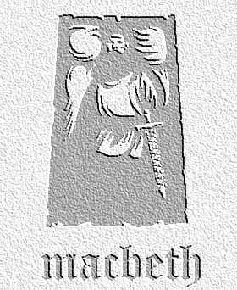
overview

Macbeth struggles with the idea of killing Duncan. When he meets his wife, he voices his doubts, but she has other ideas...
1. Using these key words as prompts, summarise Macbeth’s arguments against killing Duncan in his opening speech:

- revenge
- king
- faithful
- host
- goodness
- heaven
- unnatural

2. In this soliloquy, underline the words you feel the actor playing Macbeth should stress as he recites this important speech. Compare your answers with a partner, discussing your choices.

3. This scene shows Lady Macbeth gradually changing Macbeth’s mind over the decision to kill Duncan. Find the key lines that show the following stages in Macbeth’s speech:

- deciding he will not kill Duncan
- considering killing him but worrying about plans going wrong
- deciding that he will definitely go ahead with the murder

4. How do you think Lady Macbeth manages to convince Macbeth to go ahead with the murder in this scene? In your answer, refer to:

- her accusations against him
- her practical suggestions
- her persuasive language

5. Re-read Lady Macbeth’s lines from 54-8 (‘I have given suck...have done to this;’). What is your impression of Lady Macbeth’s character at this point in the play? How does it compare to Macbeth’s?

