Malcolm says he suspects Macduff of being a spy for Macbeth, which Macduff denies

Macduff asks Malcolm to save Scotland from Macbeth

Desperate to see Malcolm as Scotland’s saviour, Macduff makes excuses for Malcolm

Many students find this scene complicated, long and boring. There are important moments, though. Down the left hand side is a summary of the major developments of the scene. For each development, find between 1 and 3 lines from the scene that capture it, putting them together to produce a reduced version of the scene

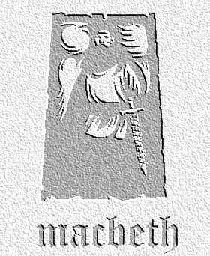
Understanding the Text
Task: Use this sheet produce an edited, five-minute version of this scene
act four scene 3

To test Macduff, Malcolm claims his own faults are worse than Macbeth’s

Macduff finally condemns Malcolm as fit to rule

Malcolm reveals he was testing Macduff’s loyalty and he has passed the test

Malcolm reveals that, future kings have the power to heal people and countries

Ross brings news of rebellion against Macbeth

Ross tells of the murder of Macduff’s family

A grief stricken Macduff, supported by Malcolm, vow their revenge

Speakers Lines

