**Year 10 Term 6 Assessment June 2019**

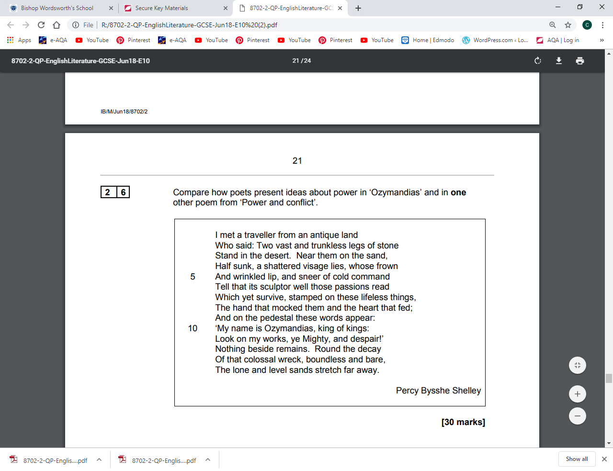

**Year 10 Term 6 Assessment June 2019**

