**Revising the Anthology:** *Learning Quotations*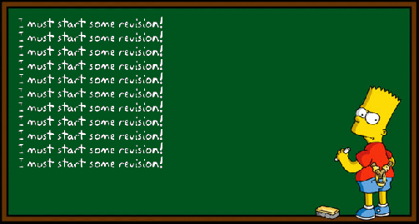

**There are a number of sections of your Literature exams which require you to memorise quotations- this is one of them! However, learning quotations for poetry doesn’t have to be as difficult or time-consuming as it would be for, say, *An Inspector Calls, Macbeth* or *Jekyll and Hyde.* This is because poetry is instantly more memorable, and there will already be sections of poems that you will remember without even trying – think about *Charge of the Light Brigade* for example! Here’s some advice, then, about going about learning the poems.**

1. Firstly, **learn all fifteen poetry titles** – preferably in Anthology order. This shouldn’t take long- perhaps invent a story that links all fifteen, or use another memory method.
2. Head fifteen sheets of paper with each of the titles.
3. Read through ALL of the poems just once.
4. Close your anthology and, for each poem, write down any memorable words, phrases that you recall for each poem. Some – like *London* and *Chare of the Light Brigade –* will be easier.
5. When finished, take stock of what you’ve done – which poems do you know best and which least? Which now require your attention?
6. You’ll probably find that you’ve written less for the more abstract / irregular poems. Go through these, and write down nine or ten important lines / phrases from each on your sheet of paper. Read through these.
7. When you’ve completed this, read the poems again, thinking about how the important words and phrases fit in.
8. Return to step 4 and repeat. How much more have you learned? Keep repeating until you’re satisfied that you have a good working knowledge of each poem.

Another idea is to use technology. Record yourself reading the poem and play it to yourself over and over again while you are revising – even other subjects. It will sink in eventually. Alternatively, find readings on YouTube, and make your own anthology of the version read loud! Play over and over again until you can start to recite chucks of the poems yourself. This will help you enormously in the exam. Some links to readings below:

[Ozymandias](https://www.youtube.com/watch?v=sPlSH6n37ts) [London](https://www.youtube.com/watch?v=7bgUMoUNgJQ) [The Prelude](https://www.youtube.com/watch?v=g7QKMh7VJog) [My Last Duchess](https://www.youtube.com/watch?v=53zCCVFN2yI) [The Charge of the Light Brigade](https://www.youtube.com/watch?v=jkffy377vq0) [Exposure](https://www.youtube.com/watch?v=d9zsX2SKM_c) [Storm on the Island](https://www.youtube.com/watch?v=eGB2xxGLjrY)

[Bayonet Charge](https://www.youtube.com/watch?v=JuCDjyCysAY&t=32s) [Remains](https://www.youtube.com/watch?v=2DHWqppktFo) [Poppies](https://www.youtube.com/watch?v=Wks8jGq701c) [War Photographer](https://www.youtube.com/watch?v=s1kdQ_udxFg) [Checking Out Me History](https://www.youtube.com/watch?v=o60RW2a2m5w) (read by Agard)

**Mr.Ennew**

**November 2016**