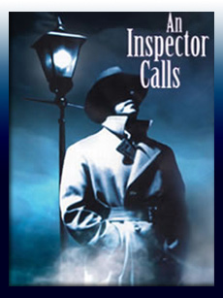

**Treatment of Women**

“very pretty”

“Wasn’t in love with her or anything”

**Class**

“girls of that sort”

“Aren’t cheap labour”

“My influence to have it refused”

“Lord and Lady Croft”

**Socialism**

“We are members of one body”

“We don’t live alone”

**Dramatic Irony**

“Nobody wants war”

“Absolutely unsinkable”

“There’ll be peace and prosperity and rapid progress”

**Young V Old**

“oh how horrible!” Sh

“*Impatiently*…yes, yes horrid” Mr B

“Nothing much has happened” Mr B

“Don’t seem to have learnt anything” Sheila

**Social Responsibility**

“like bees in a hive”

“Responsibilities as well as privileges”

“Millions of Eva Smiths and John Smiths”

**Eva Smith**

“Burnt her inside out”

“Desperate”

“Very pretty”

“She was lonely”

“Wouldn’t take any [money]”

**Inspector Goole**

“*solidity and purposefulness*”

“Each of you helped kill her”

“Taught it in fire and blood and anguish”

**Capitalism**

“soon be asking for the earth”

“Keep labour costs down”

**Gerald Croft**

“*attractive chap”*

“Wonderful Fairy Prince”

“Let me take her out of there”

“Wasn’t a police officer”

**Eric Birling**

“*Half shy, half assertive*”

“Steadily drinking”

“A chap easily turns nasty”

“I’m ashamed of you”

**Sheila Birling**

“*pretty…pleased with life*”

“She feels responsible” Inspector

“*Half stifled sob*”

“Mummy” “Mother”

**Mrs Sybil Birling**

“*cold…social superior*”

“I didn’t like her manner”

“I did nothing I’m ashamed of”

“No more than my duty”

“perfectly justified”

**Mr Arthur Birling**

“*portentous*”

“Hard headed business man”

“Wretched girl’s suicide”

“Herself into trouble”